

Finance, Information Systems, & Management Science
FINANCE 2360, FALL 2019, ASSIGNMENT #2
DUE Friday October 11, 2019 AT 12:00 noon.
Total Marks: 88
Note: For math problems, please show all of your work in your solutions. Correct answers without appropriate steps are worth 0. For all interest rates please keep all decimals.
Problem #1 (11 marks)

 | Option 1 | Option 2
 | Current cost | Cost after a period of five years
Principal | 3.80 | 6.0
 | = 3.8*10%*5
Simple interest after a period of five years | 1.90
Overall after a period of 5 years | 5.70 | 6.00
 | If simple rate of interest, personally I will opt for option number 2
Compound interest
Principal | 3.80 | 6.00
=3.8*
(1+10%)^5
Simple interest after 5 years | 6.12
Total After five Years | 6.12 | 6.00
 | If Compound rate of interest, I will prefer option 1
 | If simple rate of interest, total investment equivalent to 6 million at the end of five year
Principal | 3.80 | 6.00
 | =3.8*11.6%*5
Simple interest after 5 years | 2.20
Total After five Years | 6.00 | 6.00
 | If Simple rate of interest, 11.6% is the point of indifferent
 | If Compound rate of interest, total investment equivalent to 6 million at the end of five year
Principal | 3.80 | 6.00
 | =3.8*(1+9.55%)^5
Simple intrest after 5 years | 6.00
Total After five Years | 6.00 | 6.00
 | If Compound rate of interest, 9.55% is the point of indifferent
 | If Compound rate of interest 10%, period of indifferent
Principal | 3.80 | 6.00
 | =3.8*(1+10%)^(4.8)
Simple intrest after 5 years | 6.00
Total After five Years | 6.00 | 6.00
 | If Compound rate of interest 10%, period of indifferent is 4.8 years

Problem #2 (12 marks)
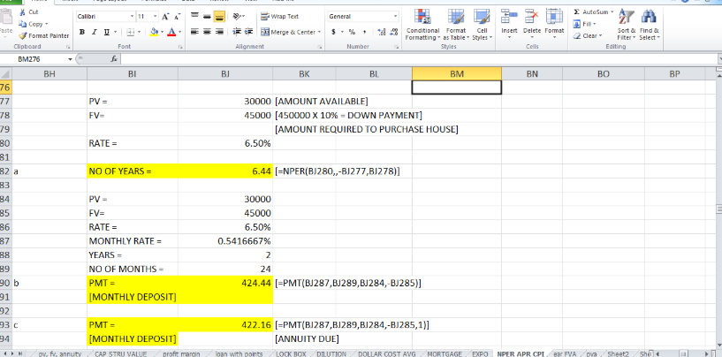 Problem #3 (7 marks)
a) $90,000 now at 3% inflation will become 90000*1.03^30 after 30 years.
i.e. $218,454 is required in retirement years (for 20 years)
Calculate the PV of these payments @7% is calculated as below. Enter the following in the financial calculator
FV = 0; 1/y = 7%; n=20; PMT = 218454; calculate PV = $2,314,305
Now we want to get $2,314,305 at the start of retirement by saving per year. Enter the following in the financial calculator to get the per month amount.
FV = 2314305; PV = 0; n= 12*30; 1/y = 12%/12; calculate PMT = $662.18
So $662.18 needs to be saved per month

Problem #4 (12 marks)

Current cost | 17,000,000
Rate of interest | 5%
Yearly amount | 850,000 | 170,000*5

b.

Current cost | 17,000,000
 | 5%
Annualized interest | 5.09% | ((1+(0.05/4))^4)-1
 | 865300 | 1700000*0.0509

c.

Present value | 17000000
Interest rate | 5%
Annual Amount | 850000 | 1700000*0.05
b.
Present value | 17000000
Quaterly Interest | 5%
Annualised Interest | 5.09% | ((1+(0.05/4))^4)-1
Annual Amount | 865300 | 1700000*0.0509
c.
Present value | 17000000
Quaterly Interest | 5%
Annualised Interest | 5.09%
Value after 2 years | $18,774,643.77 | FV(5.09%,2,0,-17000000,1)
Annual Amount | $955,629.37 | 18774643*0.0509

Problem #5 (7 marks)
Future value = P×(1+r)^n
P is present value
r is interest rate per period
n is number of periods
a)
For 3 years:
= $1,500×(1+7%)^3
= $1,837.56
For 6 years:
= $1,500×(1+7%)^6
= $2,251.10
For 9 years:
= $1,500×(1+7%)^9
= 2,757.69
b)
Interest for 1-3 years:
= $1,837.56-$1,500
= $337.56
Interest for 4-6 years:
= $2,251.10-$1,837.56
= $413.54
Interest for 7-9 years:
= $2,757.69-$2,251.10
= $506.59

Problem #6 (7 marks)
EAR = [(1 +stated rate/no. of compounding periods) ^no. of compounding periods - 1]* 100
? = ((1+8/(4*100))^4-1)*100
Effective Annual Rate% = 8.2432

Project
Discount rate | 0.082432
Year | 0 | 1 | 2 | 3 | 4
Cash flow stream | -10000 | 500 | 500 | 500 | 12500
Discounting factor | 1 | 1.082432 | 1.171659 | 1.268241 | 1.3727849
Discounted cash flows project | -10000 | 461.9228 | 426.7453 | 394.2468 | 9105.5781
NPV = Sum of discounted cash flows
NPV Project = | 388.49
Where
Discounting factor = | (1 + discount rate)^(Corresponding period in years)
Discounted Cashflow= | Cash flow stream/discounting factor
Accept opportunity as NPV is positive

Problem #7 (9 marks)
K so set everything equal to 15,000.
Then for the next four years of the daughter being in college multiply 15,000 by 4%(.04) then that answer by 4% and then the third answer by 4% .
That will be the total cost each year. Now, do 8500 times 5% (or .05) and do that again for the next five years.
Finally subtract the total cost from all four years by the total amount of money she has (8500 times .05 five times). Finally divide the final answer by six.

